***CRM THAT HELPS TO BOOK A VISA SLOT***

**1. *INTRODUCTION***

* 1. ***OVERVIEW***

*A visa slot management* project is a system that is used to track and manage the availability of visa slots, which are appointments that are required for certain visa applications. It might be used by a government agency or a visa processing center to schedule and manage appointments with applicants.

* 1. ***PURPOSE***

The purpose of applying for a visa is to obtain legal permission from a foreign government to enter and stay in their country for a specific period of time and for a specific purpose.

The visa application process is designed to assess the eligibility of the traveler to enter the country and to ensure that the purpose of their visit aligns with the visa category they are applying for. The application process typically involves submitting various documents, such as a passport, travel itinerary, proof of funds, and a visa application form.

1. **PROBLEM DEFINITION & DESIGN THINKING**

***2.1*** ***EMPATHY MAP***

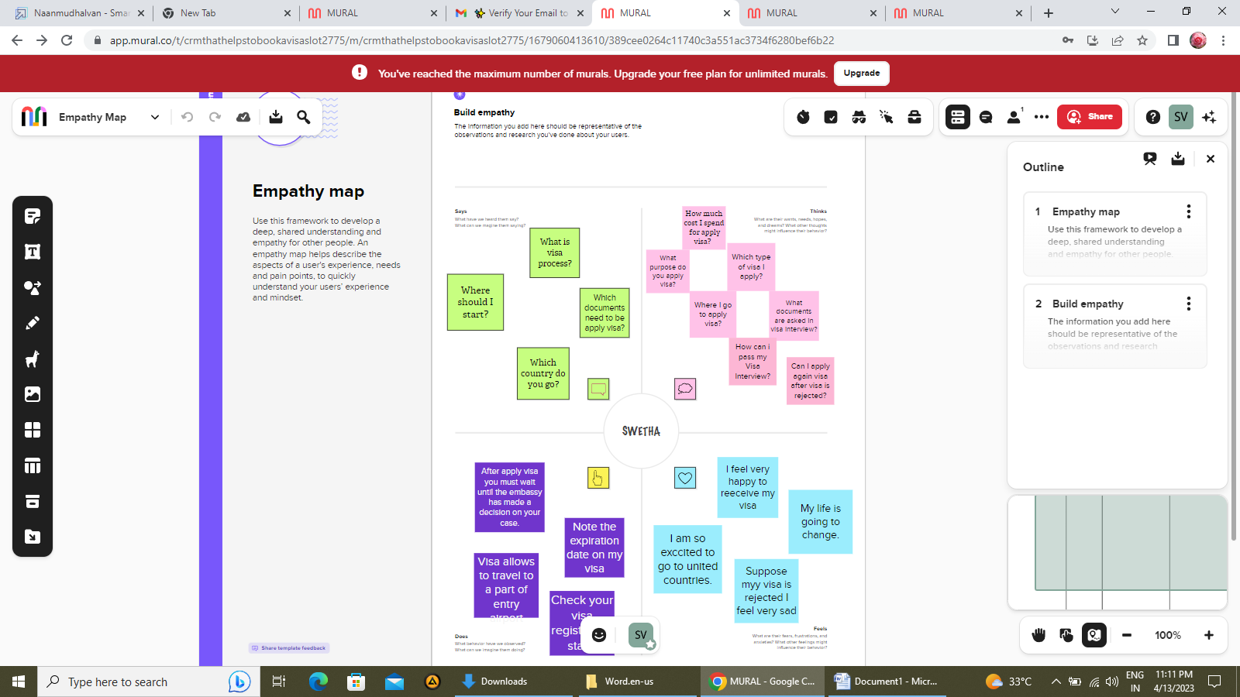

* 1. ***IDEATION & BRAINSTORMING MAP***

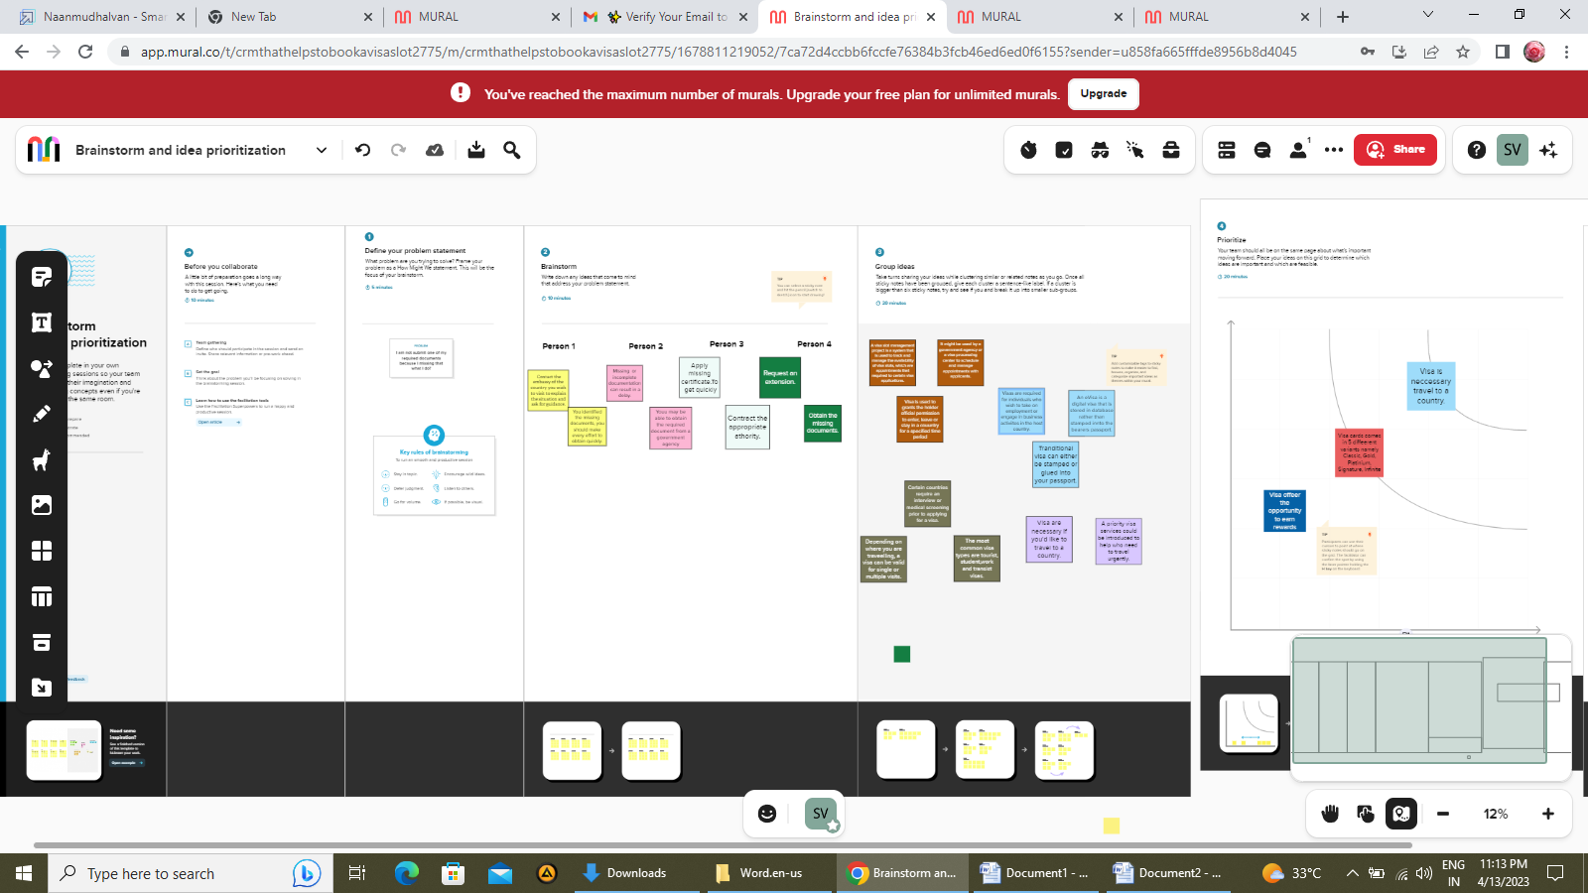

1. ***.RESULT***

***3.1 DATA MODEL:***

|  |  |
| --- | --- |
| **OBJECT NAME** | **FIELDS IN THE OBJECT** |
| Passport | |  |  | | --- | --- | | Field Label | Data type | | Full name | Text | | Passport number | Text | | Contact number | Number | | Permanent address | Text | |
| Visa slot | |  |  | | --- | --- | | Field Label | Data type | | Location | Text | | Time | Time | | Passport number | Master detail relationship | | Visa slot number | Text | |
| Payment | |  |  | | --- | --- | | Field Label | Data type | | Payment mode | Text | | Card Number | Number | | Transaction id | Auto number | | Cancel Transaction | Text | | Visa slot number | Master detail relationship | |
| Reschedule/Cancel | |  |  | | --- | --- | | Field Label | Data type | | Passport number | Master detail relationship | | Location | Text | | Time | Time | | Cancel | Text | | Status | Text | |

***3.2 ACTIIVITY & SCREENSHOT***

***MILESTONE-1: CREATION OF DEVELOPER ORG.***

**ACTIVITY 1**: **Creating Developer Account**

I go developers.salesforce.com/ website. Next I create my salesforce account using given instructions of my project pdf.

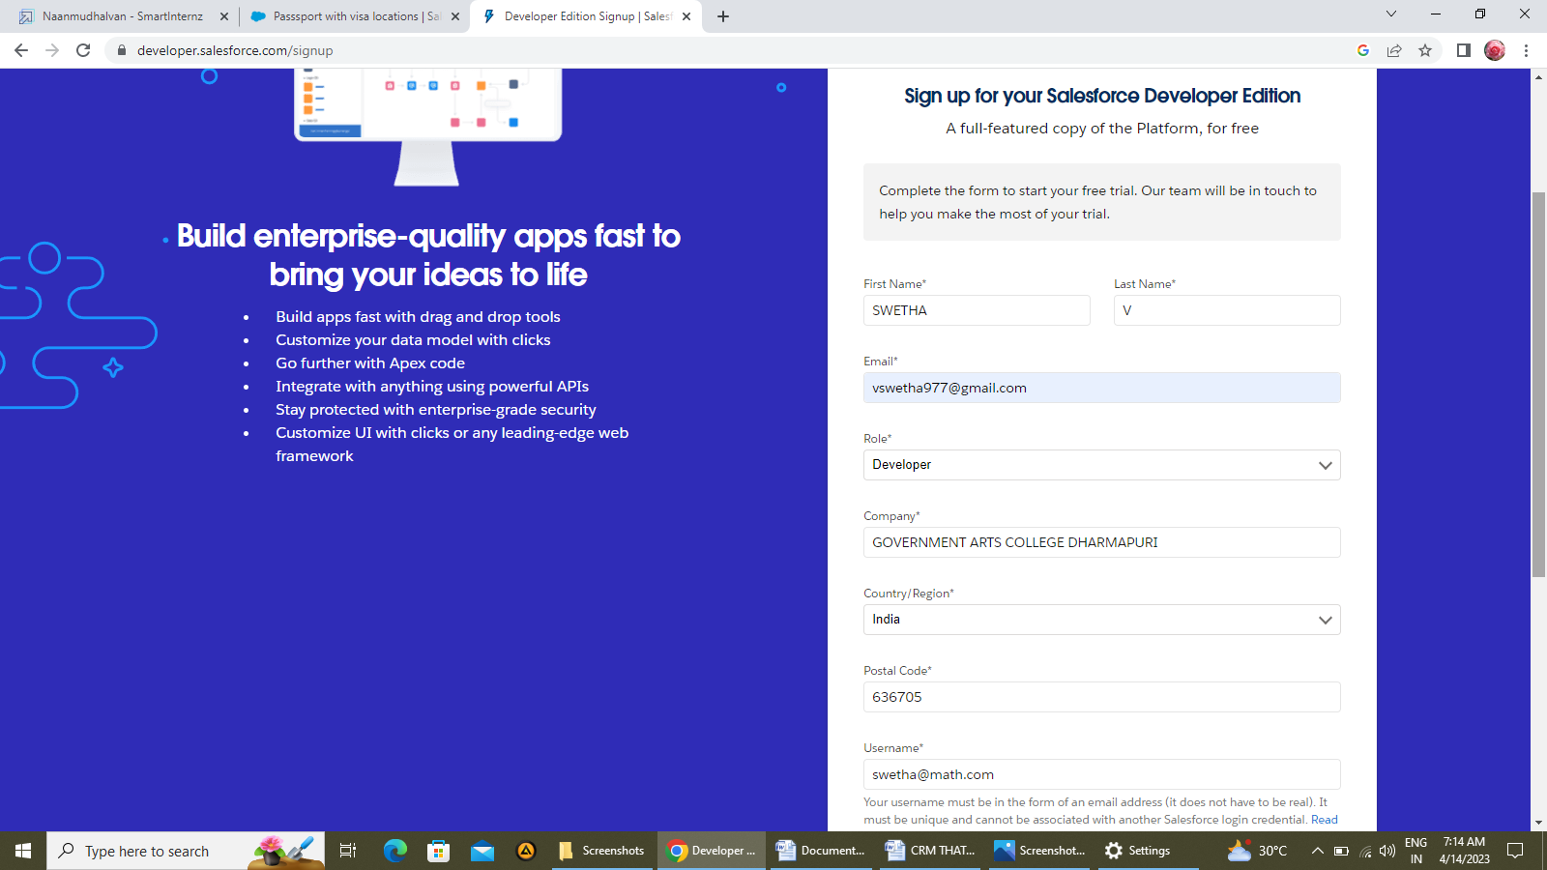

***MILESTONE-2: OBJECTS:***

**ACTIVITY -1:**

**Create custom object: Passport**

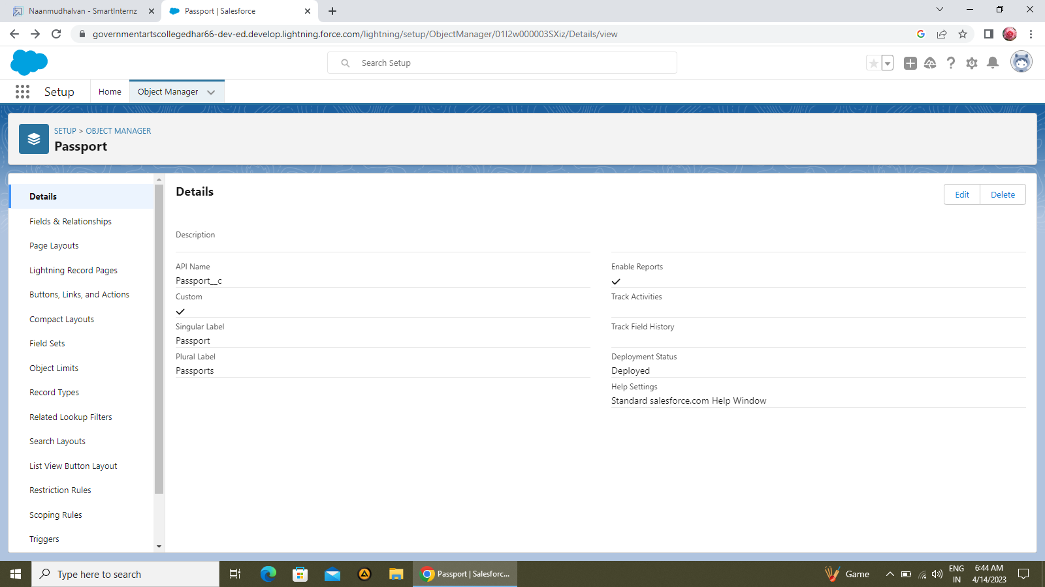

**Create custom object: Visa slot**

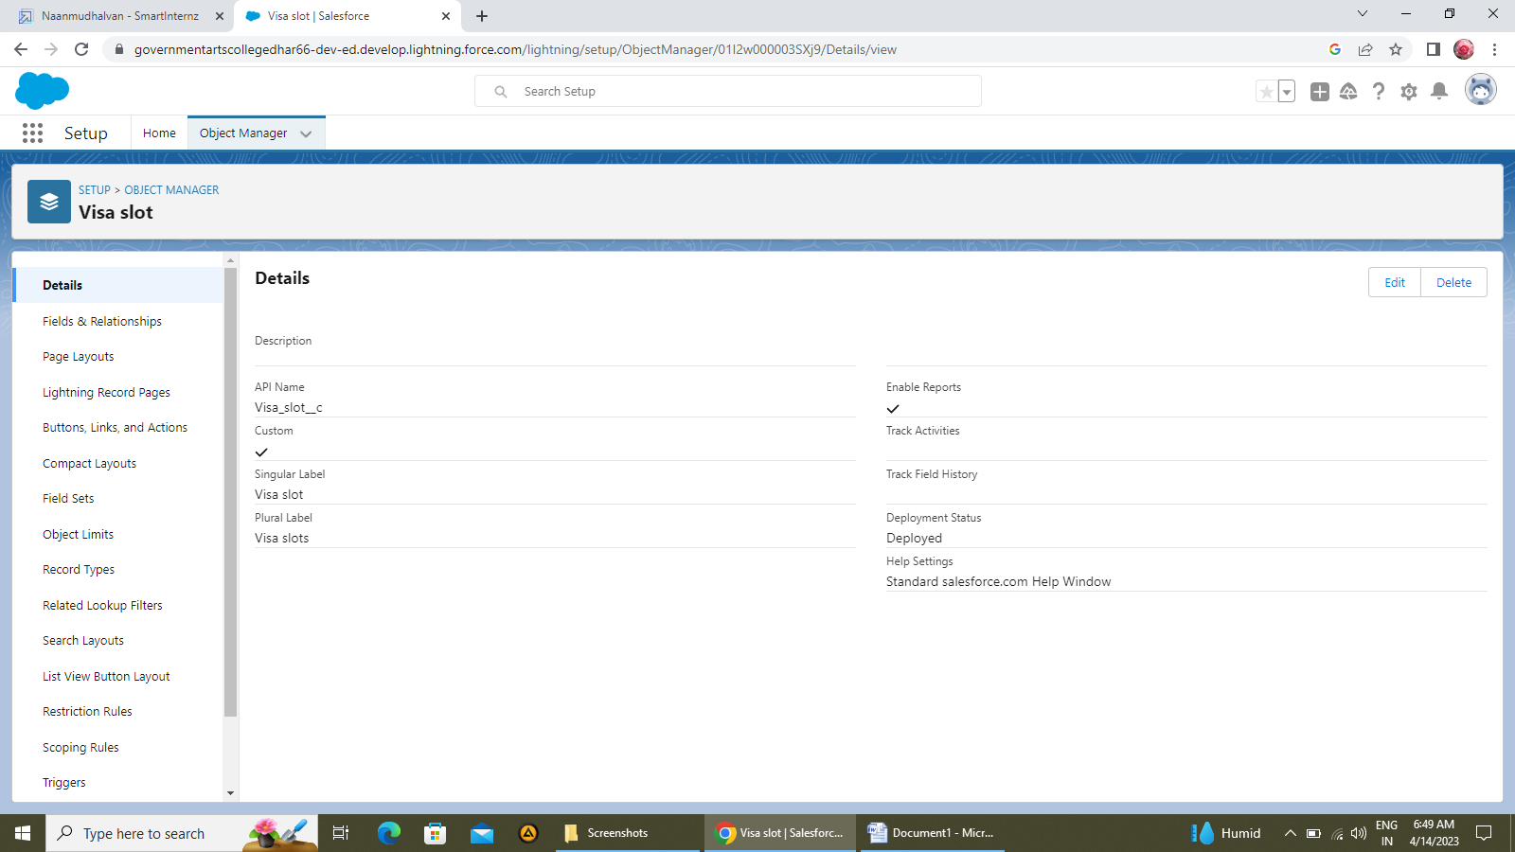

**Create custom object: Payment**

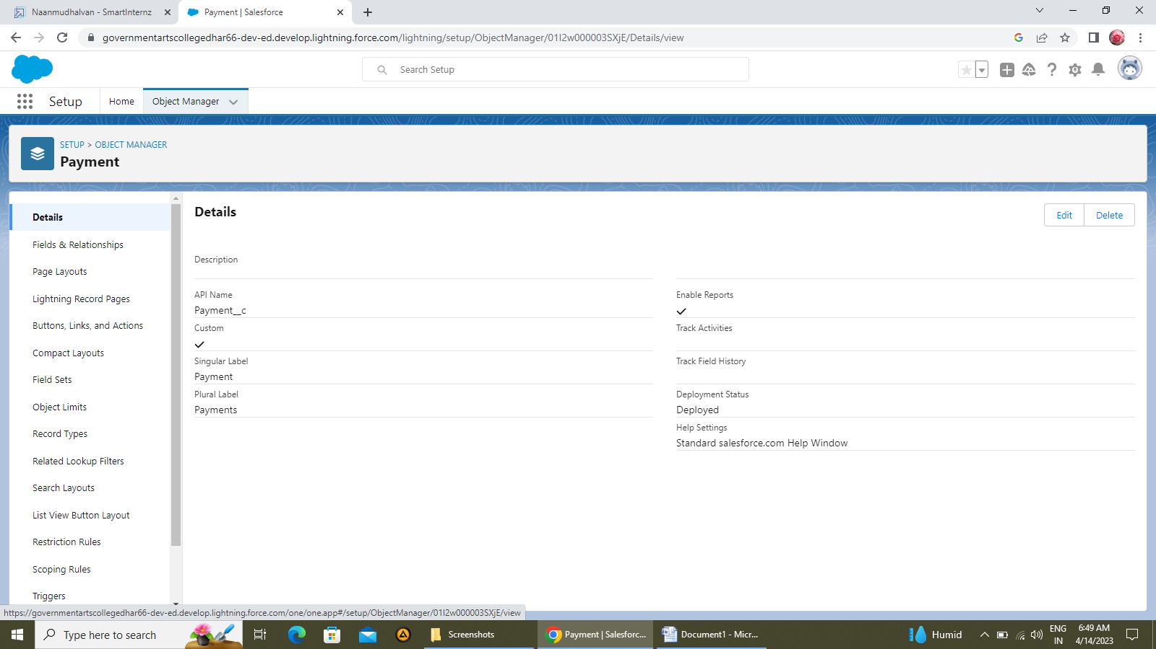

**Create custom object: Reschedule/Cancel**

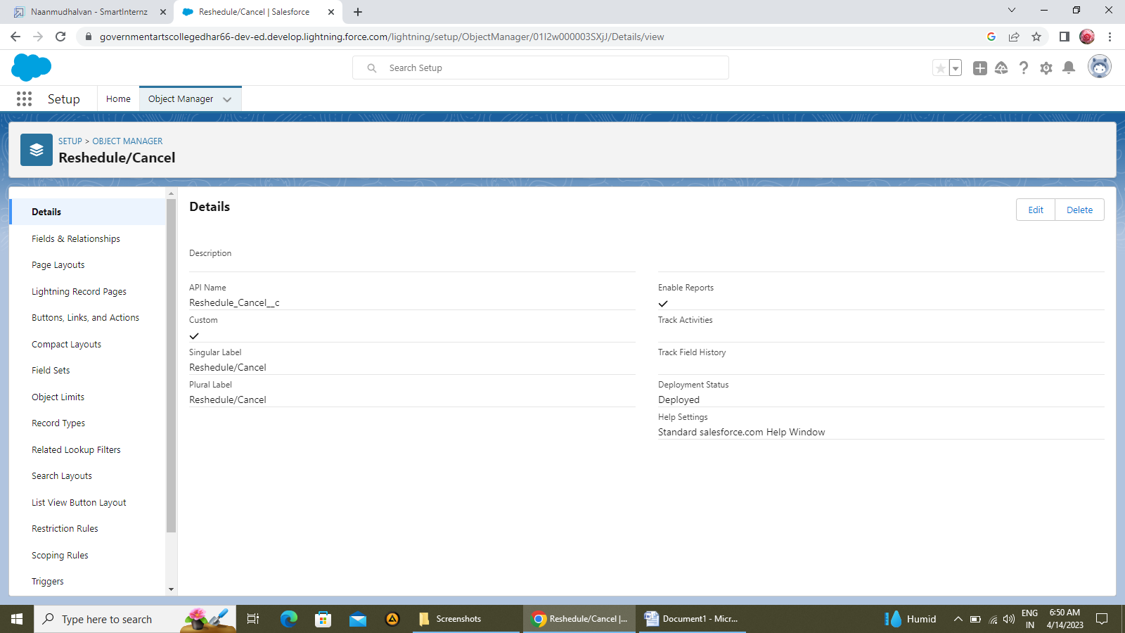

**ACTIVITY 2**:

**Creation of fields on custom object: Passport**

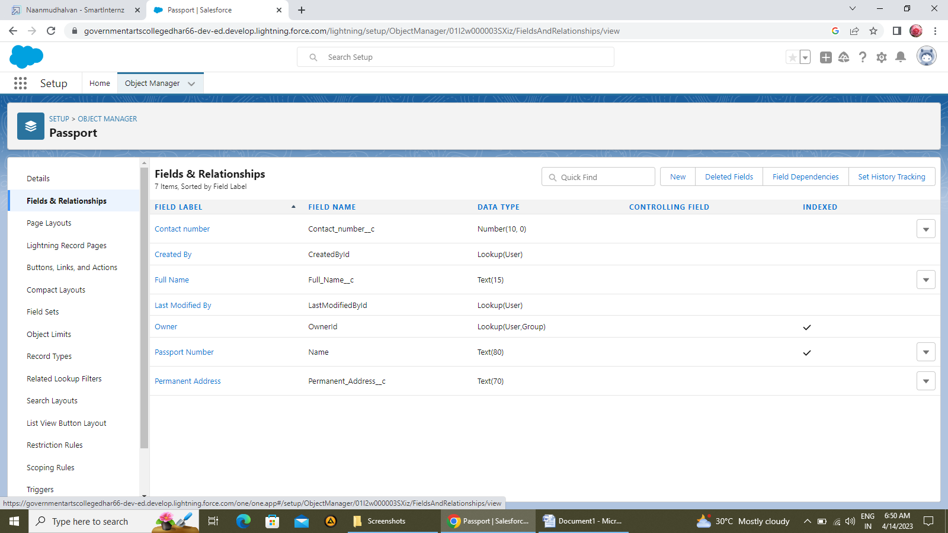

**Creation of fields on custom object: Visa slot**

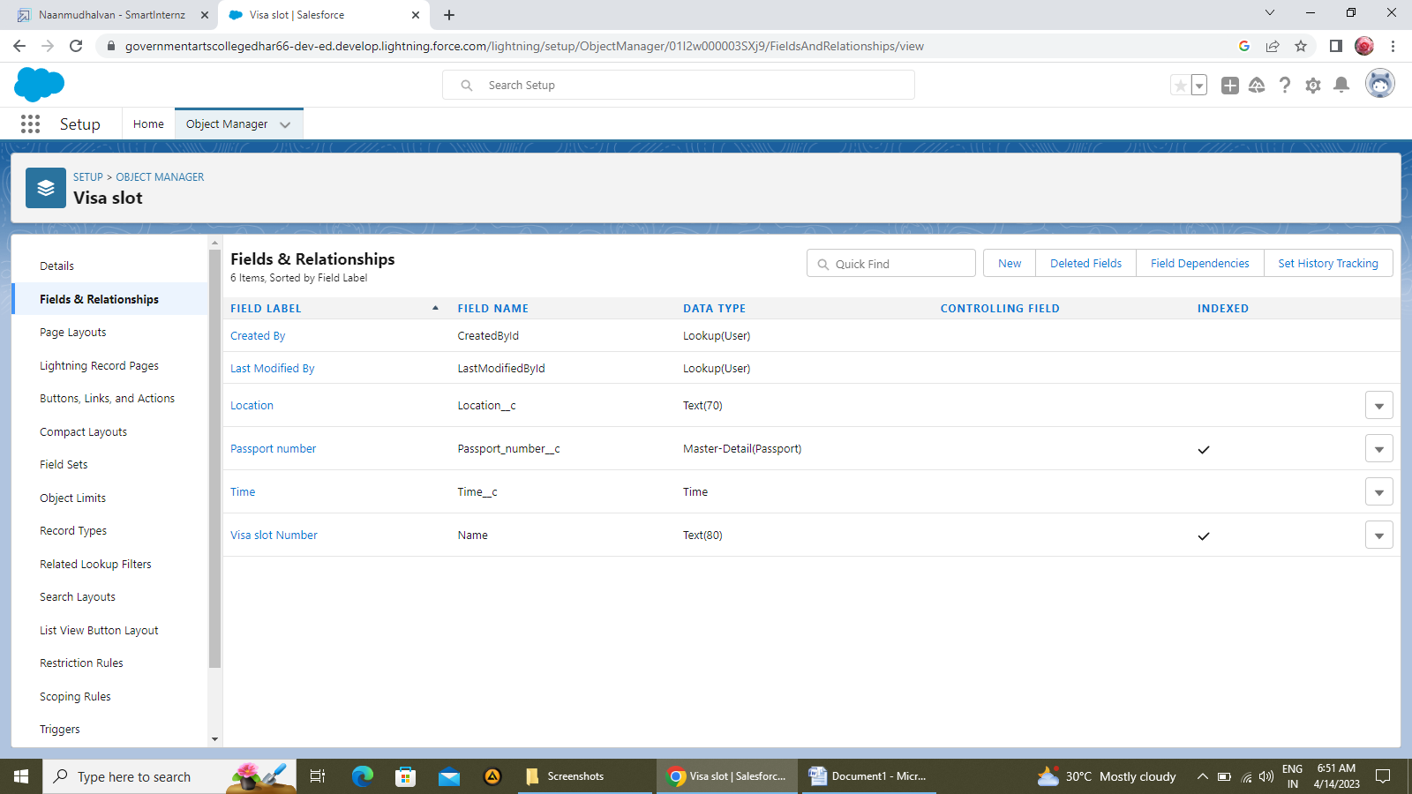

**Creation of fields on custom object: Payment**

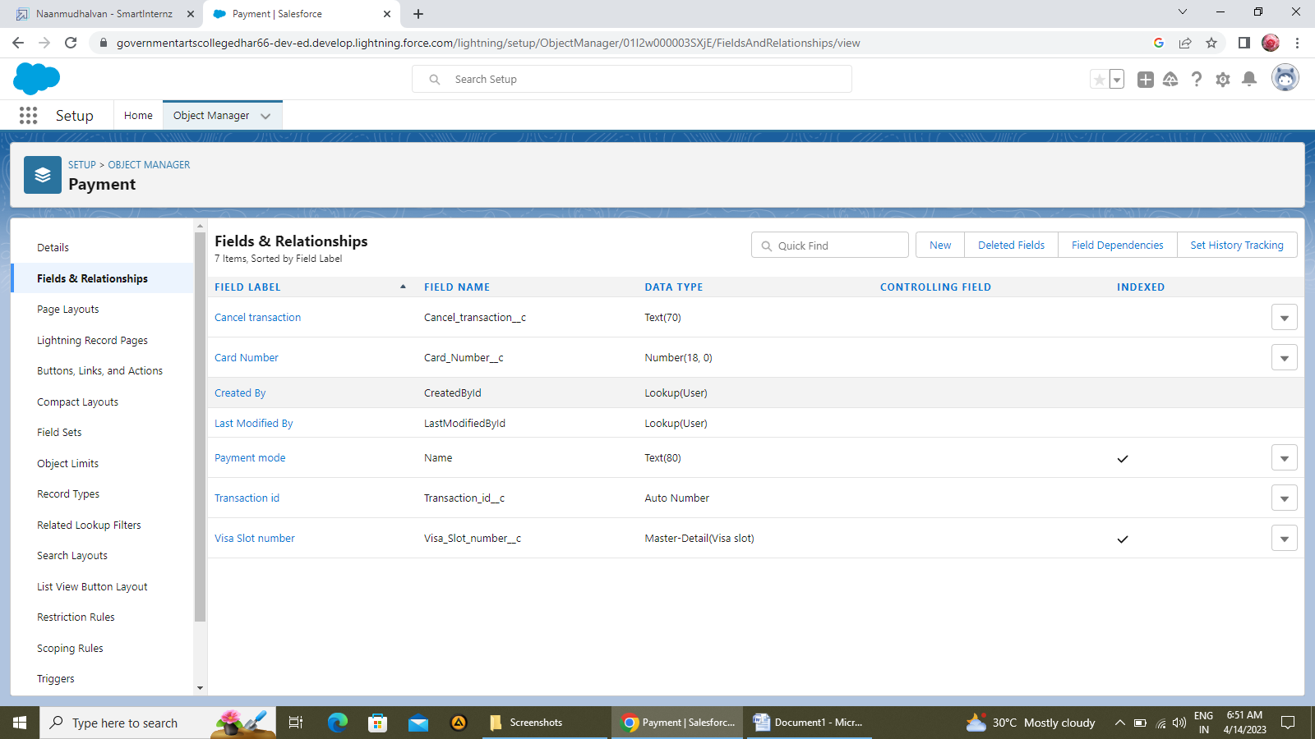

**Creation of fields on custom object: Reschedule/Cancel**

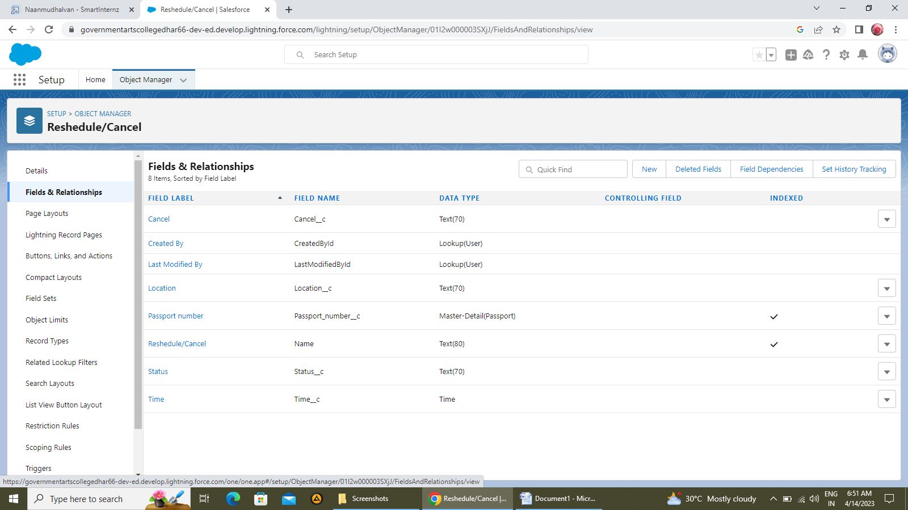

***MILESTONE-3: RELATIONSHIP B/W OBJECTS:***

**ACTIVITY -1: Creation of relationship**

To create relationship between Passport and Visa.

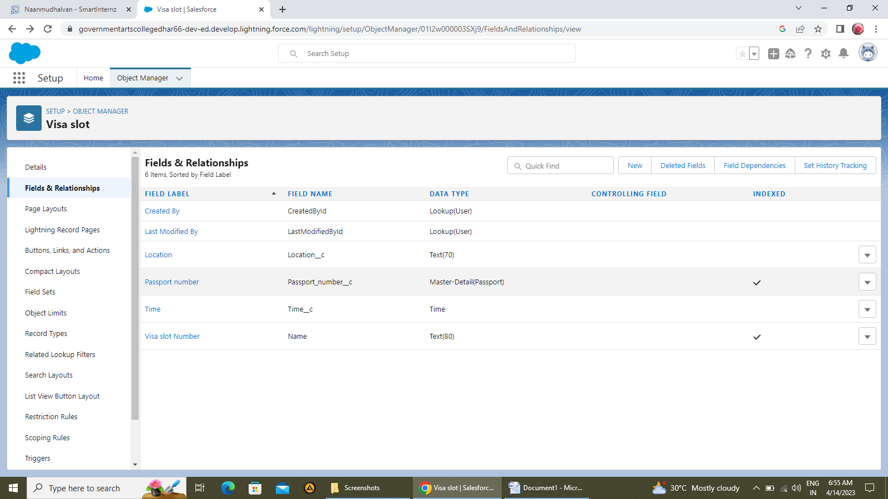

***MILESTONE-4: APP***

**ACTIVITY: Creation of app**

To create BOOK MY VISA lightning app.

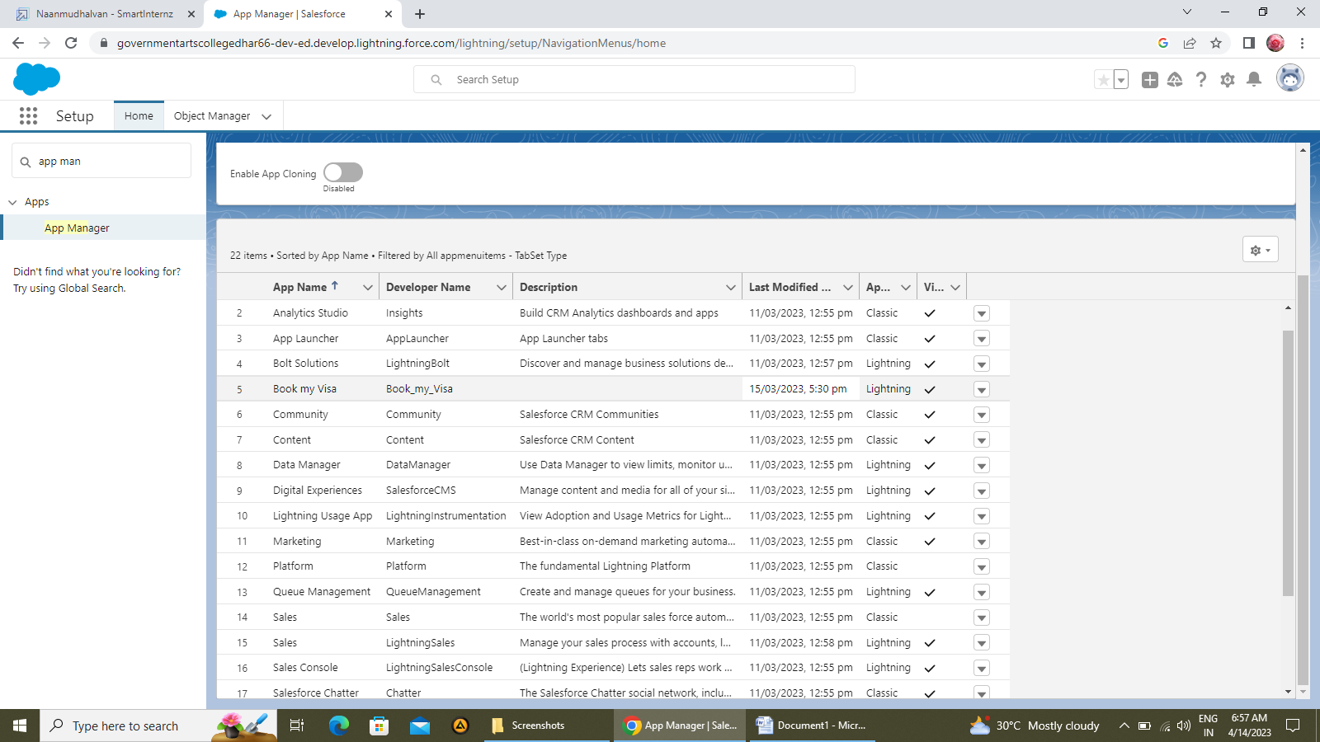

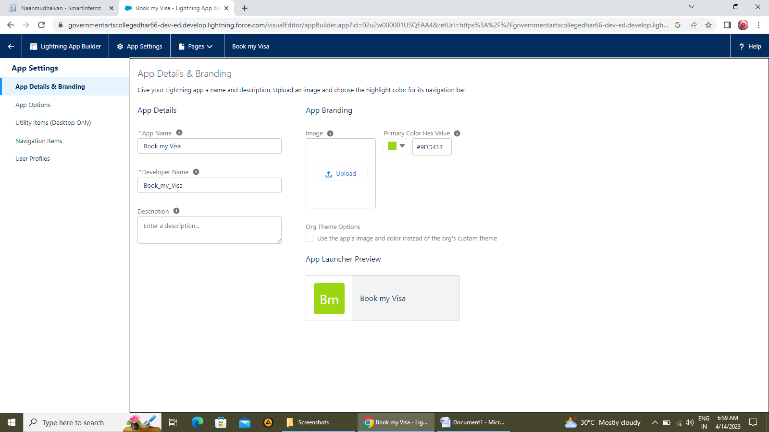

***MILESTONE-5 USER:***

**ACTIVITY -1: Creation of user**

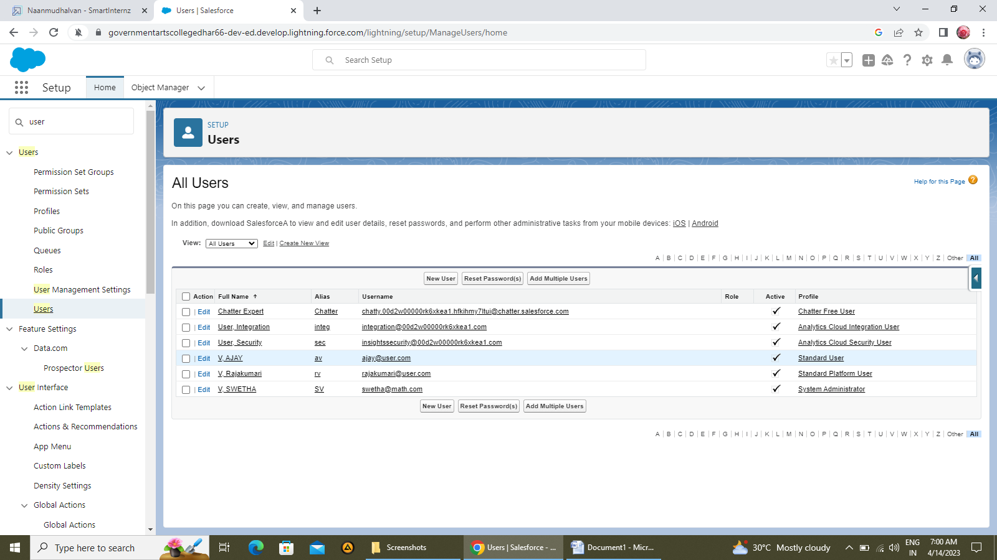

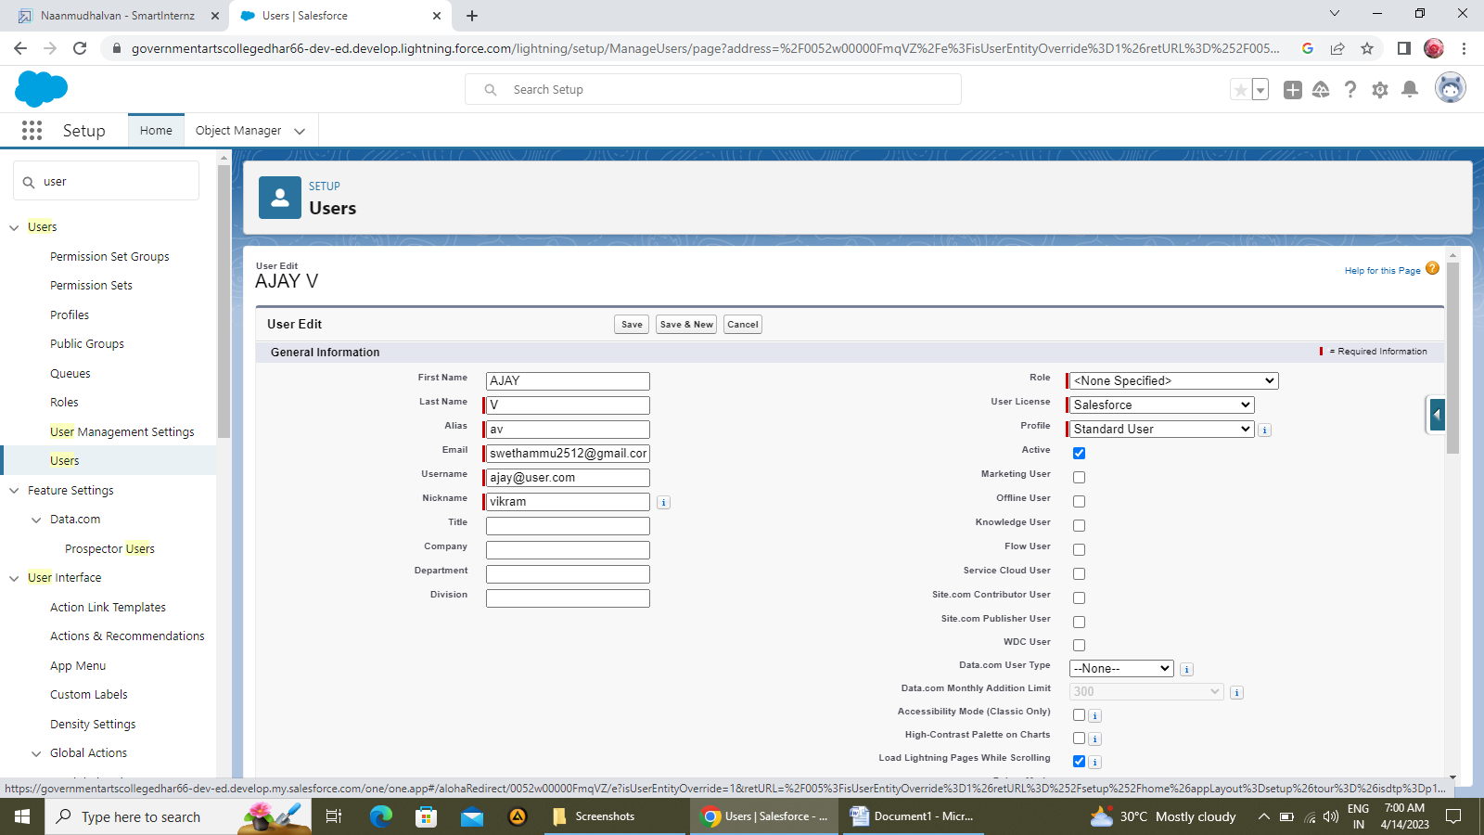

**ACTIVITY -2: OWD: Organization*****wide default settings****.*

This can be used to give permissions to the organization wide and it can be used for restrict the access we can control the record level access.

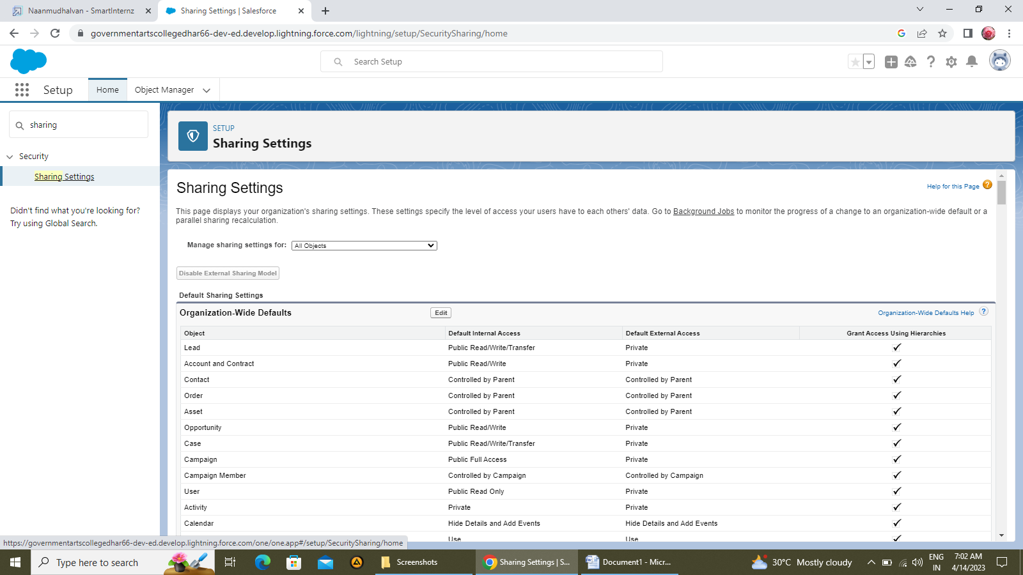

### C:\Users\SWETHA V\Pictures\Screenshots\Screenshot (44).png

***MILESTONE-6 REPORTS***

**ACTIVITY -1: Creation of report**

Creation of report ensure that update preview automatically is selected which is available at the right side of the report page.

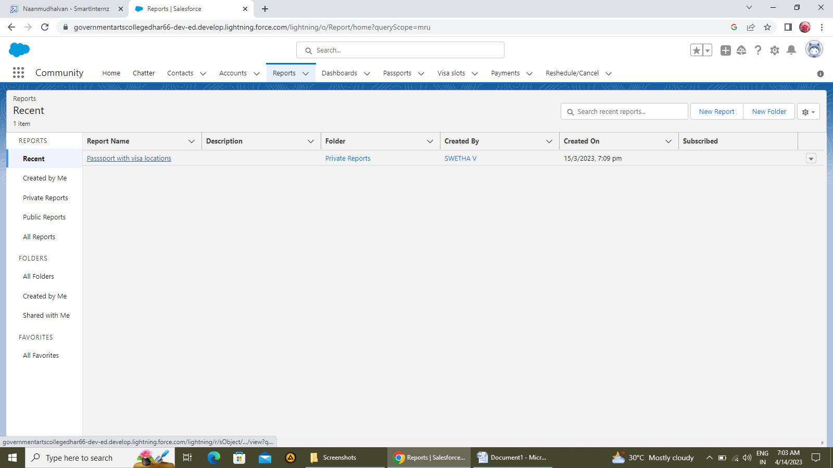

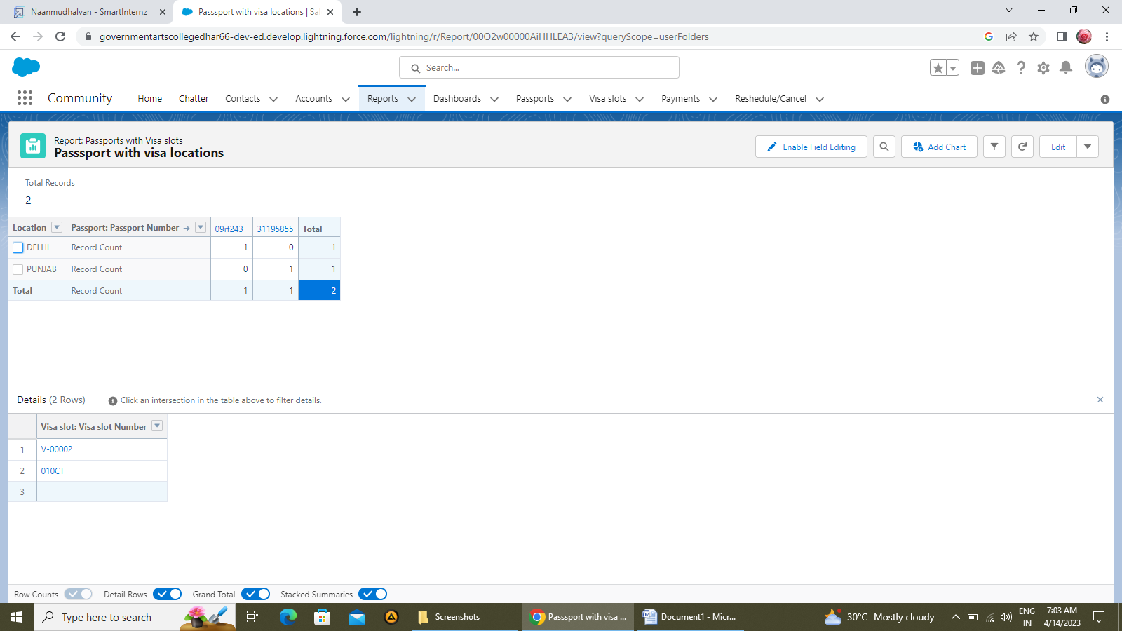

***MILESTONE-7 DASHBOARDS:***

Dashboards in salesforce are a graphical representation of reports. It shows data from source reports as visual components.

**ACTIVITY: Creation of Dashboard**

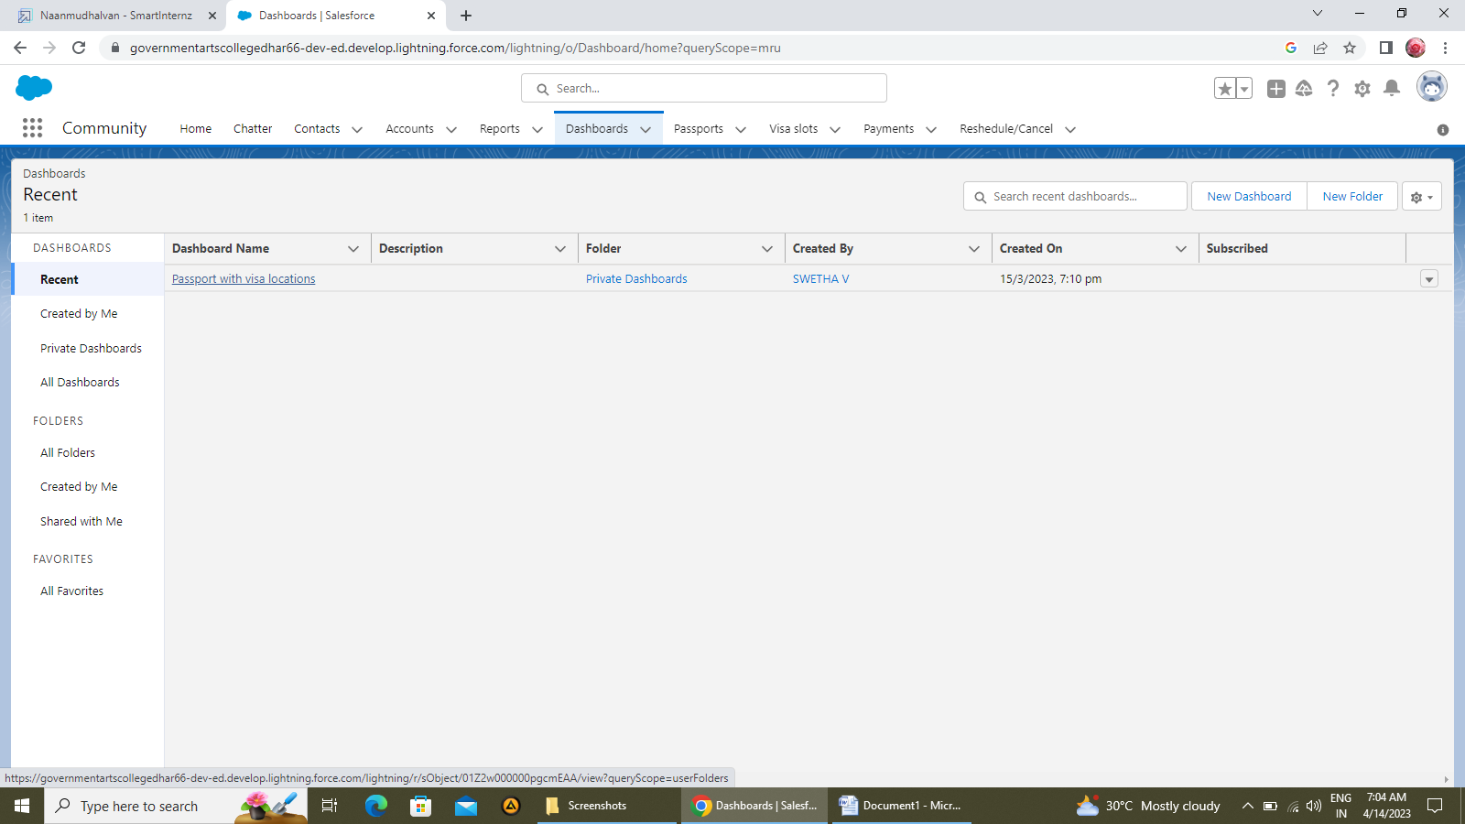

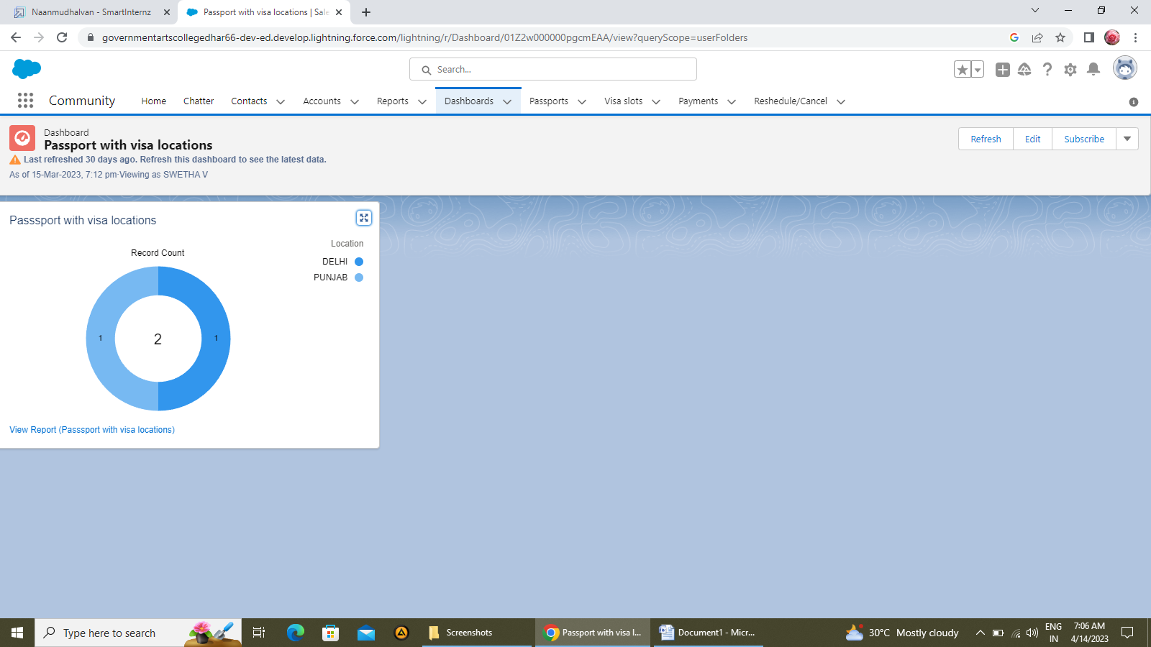

**4. Trailhead Profile Public URL**

Team Lead SWETHA V

<https://trailblazer.me/id/swethamath>

Team member DEVIPRIYA R

<https://trailblazer.me/id/devir32>

Team member NIVETHA P

<https://trailblazer.me/id/npoothumani>

Team member SUMITHRA S

<https://trailblazer.me/id/sumithrasrini>

**5. ADVANTAGES & DISADVANTAGES**

***Advantages:***

* **Business opportunities:** Having a visa can open up business opportunities in foreign countries, allowing you to establish international partnerships and expand your business globally.
* **Longer stays:** Many countries offer visas that allow for longer stays, which can be beneficial if you plan to travel extensively or for an extended period.
* **Increased travel options:** With a visa, you will have the freedom to travel to more destinations and explore different cultures opening up new opportunities for you.
* **Smooth travel:** Having a visa in advance can make your travel experience smoother a d less stressful, as you will have already gone through the visa application process and obtained.
* **Saves time:** Booking a visa appointment in advance can help you save time by allowing you to plan your trip accordingly.
* **Ensures smooth processing:** Booking a visa appointment in advance can also help ensure that your visa application is processed smoothly and efficiently.

***Disadvantages :***

* **Time consuming process:** Applying for a visa can be a time-consuming process, as it often involves submitting a range of documents and waiting for processing times that can vary depending on the country and type of visa.
* **Cost:** Visa fees can be expensive, and additional costs may be incurred for travel, accommodation, and other expenses associated with the application process.
* **Restrictions:** Some visas may come with restrictions, such as limiting the duration of stay, prohibiting certain activities, or requiring additional documentation or permits.
* **Limited assistance:** While visa booking services may be able to provide some assistance in navigating the visa application process, they may not be able to answer all of your questions or provide the level of support your need.
* **Language barriers:** Visa applications may require documents to be translated into the language of the country where the visa is being sought, which can add additional costs and complications

**6. APPLICATIONS**

* When you travel one country to other country you need visa.
* Visa requirment vary depending on the country and the nationality of the traveler.
* Most countries require visitors to have a visa if they are planning to stay for an extended period or engage in certain activities, such as work or study.
* Some countries may allow visa-free entry for short-term tourism or business visits, depending on the traveler’s nationality.

7. CONCLUSION

Visa slot management is used to apply visa online. It is very useful to users. CRM brings together various departments, such as sales and marketing, to ensure a uniform approach which ultimately to increasing the company’s success.

8. FUTURE SCOPE

1. Use block chain technology to enhance security and reduce fraud.
2. In terms of travel restrictions and visa policies, it is difficult to predict what changes may occur in the future , as they are often driven by political and economic factors. However, with the ongoing COVID-19 Pandemic, it is likely that travel restrictions and health-related requirements will continue to evolve and impact the visa application process.
3. In future much advancement include in visa slot management.